**LAB # 04**



**CS-II LAB**

Submitted by: Maaz Habib

Registration No.: **20PWCSE1952**

Class Section: **C**

“On my honor, as student of University of Engineering and Technology, I have neither given nor received unauthorized assistance on this academic work.”

Submitted to: **Engr. Faiz Ullah**

**29 Nov, 2021**

Department of Computer Systems Engineering

University of Engineering and Technology, Peshawar

**Series R, L, C Circuits**

This exercise examines the voltage and current relationships in series R, L, C networks, of particular importance is the phase of the various components. How Kirchhoff’s Voltage Law is extended for AC circuits. Both time domain and phasor plots of the voltages are generated.

**Theory Overview:**

**Each element has a unique phase response:**

As for resistors, the voltage is always in phase with the current, for capacitors the voltage always lags the current by 90 degrees, and for inductors the voltage always leads the current by 90 degrees. Due to the phase response, Kirchhoff’s Voltage Law must be computed using vector (phasor) sums rather than simply relying on the magnitudes. All computations of this nature, such as a voltage divider, must be computed using vectors.

**Equipment:**

1. AC Function Generator

2. Oscilloscope

**Procedure:**

**1.** Using Figure 1 with VIN =2Vp-p sine at 10 kHz, R=1kΩ, L=10mH and C=10nF, determine the theoretical inductive and capacitive reactance and circuit impedance, and record the results in Table 1. Using the voltage divider rule, compute the resistor, inductor and capacitor voltages and record them in Table 2.

**2.** Build the circuit of Figure 1 using R=1kΩ, L=10mH and C=10nF. Set the generator to a 10 kHz sine wave and 2 Vp-p. Using oscilloscope measure the signals. Unfortunately, it is impossible to see the voltages of all the three components simultaneously using only two probes of the oscilloscope. To obtain the proper readings, place one probe on the function generator to see the input signal and the second probe across the last element. This step is repeated three times. The first time the components are so arranged that capacitor is the last component, the second time inductor is connected as the last component and finally resistor is made the last component. The peak-to- peak voltages and phase angles of each one of the three components, relative to the source are thus determined in turn. Thus Vs, VC, VL and VR are measured. Record in Table 2.

**3.** Compute the deviations between the theoretical and experimental values of Table 2 and record the results in the final columns of this table.

**4.** Based on the experimental values, determine the experimental Z, XL and XC values via Ohm’s Law

(i=VR/R, XL=VL/i, XC=VC/i, Z=Vin/i) and record back in Table 1 along with the deviations.

**5.** Create a phasor plot showing VIN, VL, VC, and VR.

**6.** Repeat the experiment for 1nF capacitor, 1mH inductor and 1kΩ resistor.

**Data Table:**

|  |  |  |  |
| --- | --- | --- | --- |
|  | **Theoretical** | **Experimental** | **%Deviation** |
| **XC** | 1592 | 1564.2 | 1.7% |
| **XL** | 628 | 646.6 | 2.9% |
| **Z** | 1389 | 1357.6 | 2.25% |
| **Ѳ** | -43.9 | -42.5 | 3.2% |

**Table 01:**

|  |  |  |  |
| --- | --- | --- | --- |
|  | **Theoretical** | **Experimental** | **%Deviation** |
| **VC** | 2.29 | 2.3 | 0.43% |
| **VL** | 0.904 | 0.95 | 5% |
| **VR** | 1.14 | 1.5 | 4.1% |
| **Vs** | 2 | 2 | 0% |
| **Ѳ** | -43.9 | -42 | 4.3% |

**Screenshots:**

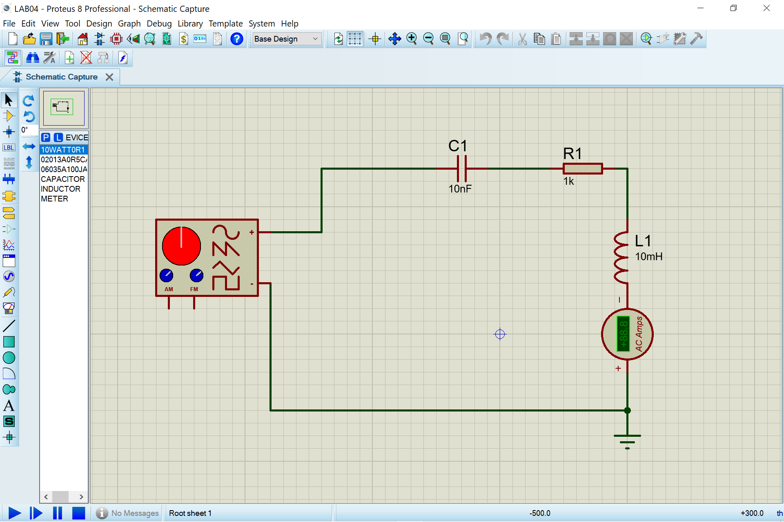

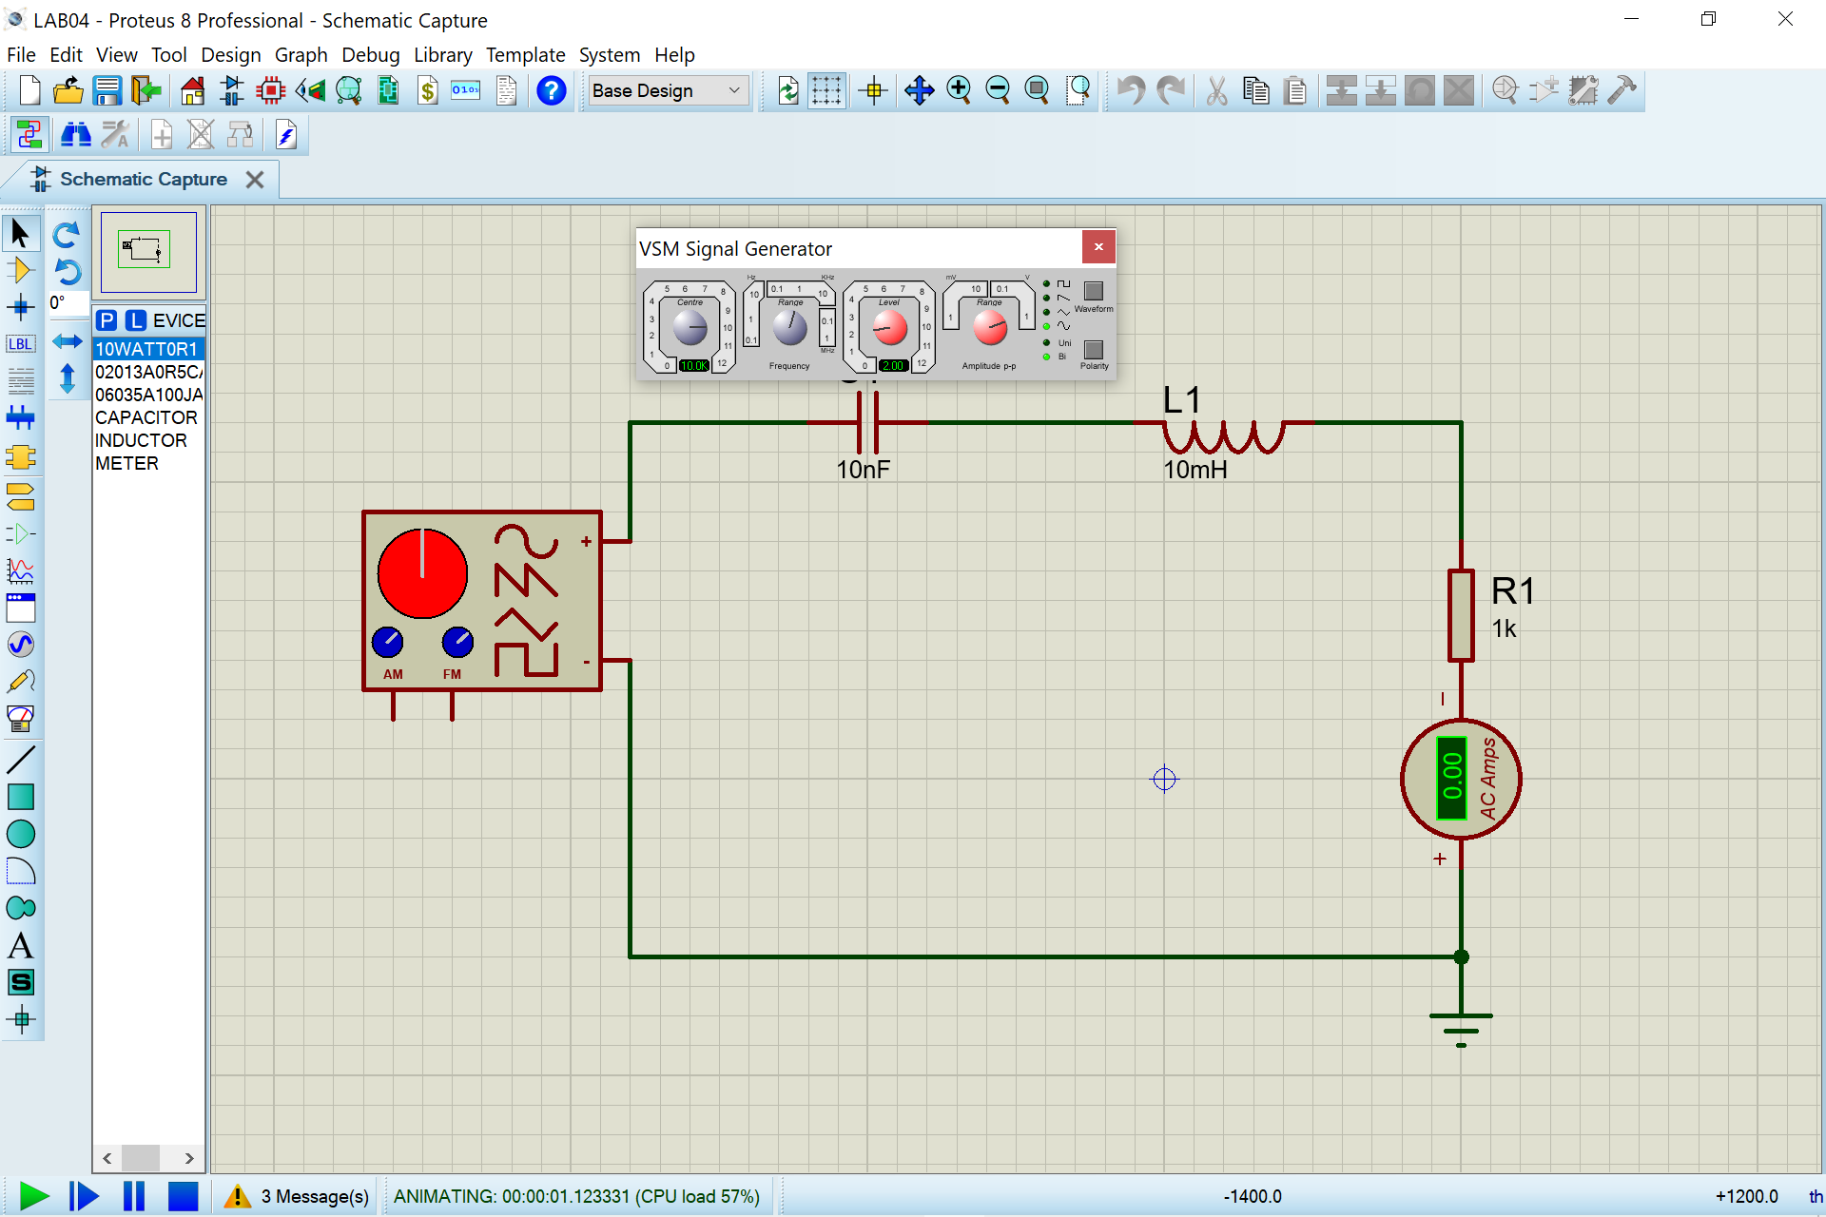

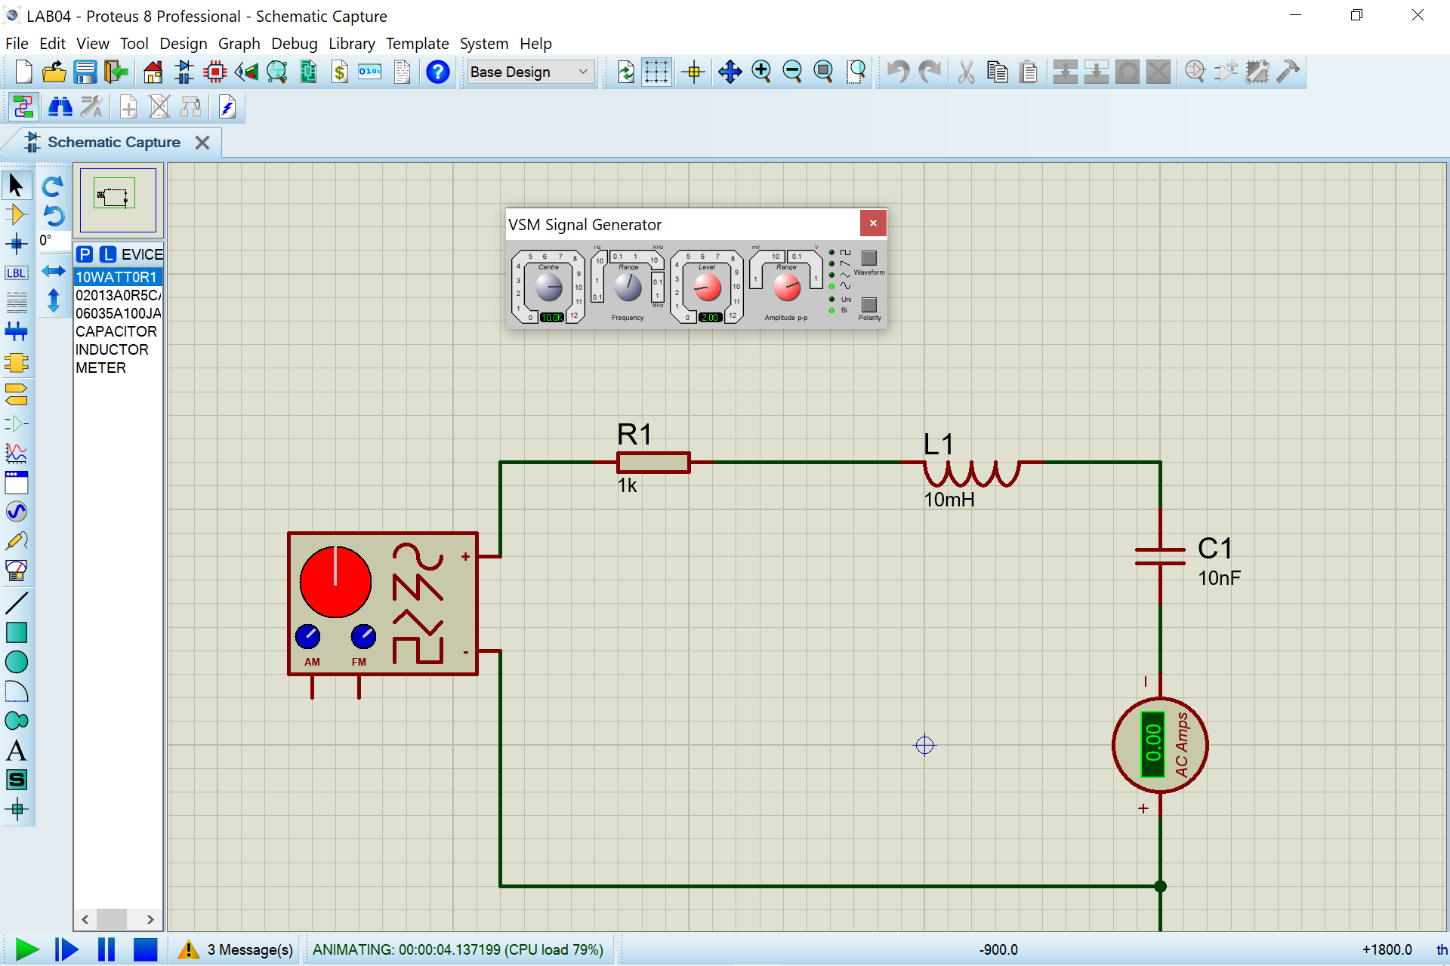

**Questions & Answers:**

**Ans#01:**

**R=resistive component**

**L=Inductive and C is Capacitive.**

In R component, the current and Voltage vectors are in phase with each other. The phase angle between the two is ZERO. In L component, the phase angle between the current and Voltage vector is -90 degree and the current vector lags the voltage vector by 90 degrees. In C component, the phase angle between the current and voltage vectors is +90 degree i.e. the current vector leads the voltage vector by 90 degree.

**Ans#02:**

Yes, based on measurements, Kirchhoff’s voltage law does apply to the circuit.

**Ans#03:**

Well, it will be shifted upward.

**Ans#04:**

Well, the phasor will be shifted downward.